Physics 20 Lesson 18H Torque

Angular acceleration and torque
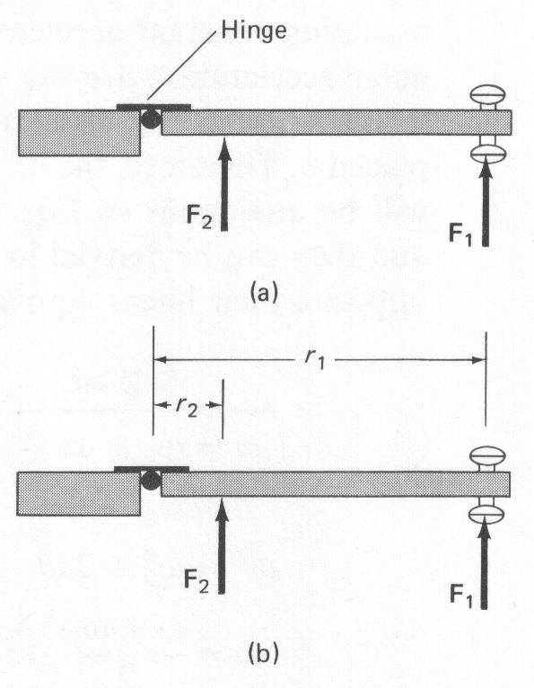
In Lesson 9H, we discussed rotational kinematics – the description of rotational motion in terms of angle, angular velocity, and angular acceleration. Now we discuss the dynamics, or causes, of rotational motion. Just as we found analogies between linear rotational motion for the description of motion, so rotational equivalents for dynamics exist as well. For example the rotational equivalent of Newton's first law states that a freely rotating body will continue to rotate with constant angular velocity as long as no forces (or, as we shall see shortly, no torques) act to change that motion. More difficult is the question of a rotational equivalent for Newton's second law; that is, what gives rise to angular acceleration? To make an object start rotating about an axis clearly requires a force; but the direction of this force, and where it is applied, are also important. Take, for example, an ordinary situation such as the door in the figure to the right. If you apply a force F₁ to the door as shown, you will find that the greater F₁ is the more quickly the door opens. But now if you apply the same magnitude force at a point closer to the hinge, say F₂, you will find that the door will not open so quickly. The effect of the force is less.

The angular acceleration of the door is proportional not only to the magnitude of the force, it is also proportional to the perpendicular distance from the axis of rotation to the line along which the force acts. Thus, if the distance r₁ in the figure to the right is three times larger than r₂ then the angular acceleration of the door will be three times as great, assuming that the magnitudes of the forces are the same. To say it another way, if r₁ = 3r₂ then F₂ must be three times as large as F₁ to give the same angular acceleration. The distances r₁ and r₂ are called the lever arms or moment arms of the respective forces. The angular acceleration, then, will be proportional to the product of the force times the lever arm. This product is called the moment of the force, or torque, and is abbreviated τ (Greek lowercase letter tau). The angular acceleration a of an object is directly proportional to the net applied torque, τ:

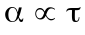

Force and the lever arm
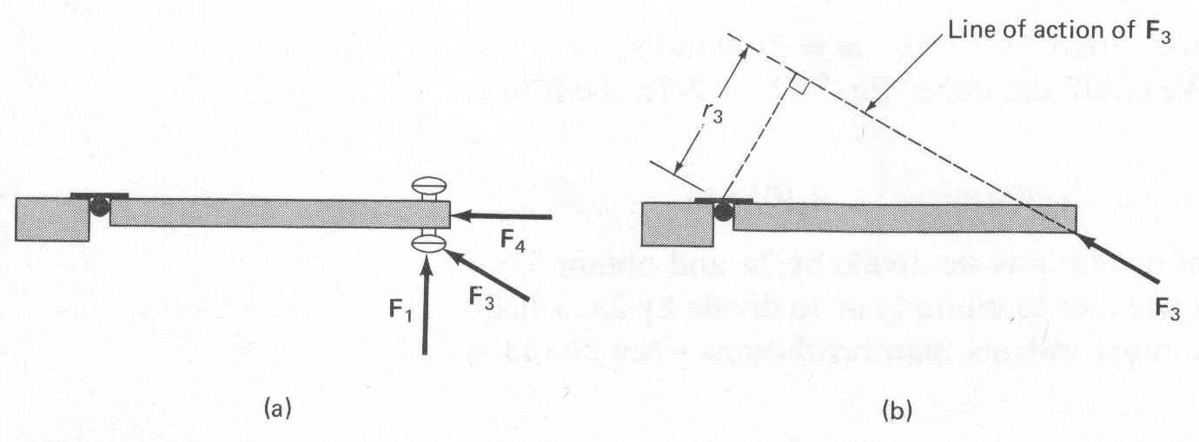
We define the lever arm as the perpendicular distance of the axis of rotation from the line of action of the force. (we mean the distance which is perpendicular to both the axis of rotation and to an imaginary line drawn along the direction of the force); we do this to take into account the effect of forces acting at an angle. It is clear that a force applied at an angle, such as F₃ in the figure to the right, will be less effective than the same magnitude force applied straight on, such as F₁. And if you push on the end of the door so that the force is directed at the hinge (i.e. the axis of rotation), as indicated by F₄, the door will not move at all.

The lever arm for a force such as F₃ is found by drawing a line along the direction of F₃ (this is the “line of action” of F₃) and then drawing another line from the axis of rotation perpendicular to the first line (and also perpendicular to the rotation axis). The length of this second line is the lever arm for F₃ and is labeled r₃.

The torque associated with F₃ is then r₃•F₃. This short lever arm and the corresponding smaller torque associated with F₃ is consistent with the observed fact that F₃ is less effective in opening the door than is F₁. When the lever arm is defined in this way, experiment shows that the relation is valid in general. Notice in that the line action of the force F₄ in the figure above passes through the hinge and hence its lever arm is zero. Consequently zero torque is associated with F₄, and it gives rise to no angular acceleration, in accord with everyday experience.

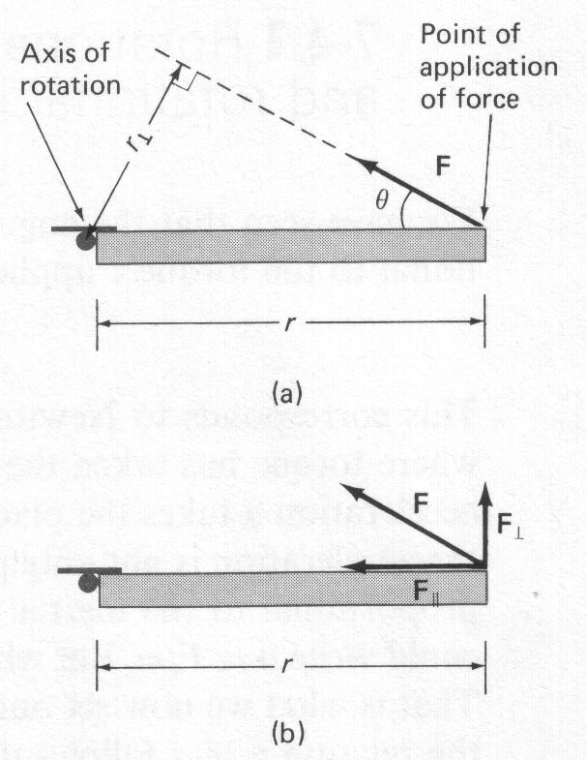
In general, then, we can write the torque about a given axis as

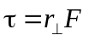

where r, is the lever arm and the (⊥) symbol reminds us that we must use the distance from the axis of rotation that is perpendicular to the line of action of the force. An alternate but equivalent way of determining the torque associated with a force is to resolve the force into components parallel and perpendicular to a line joining the point of application of the force to the axis as shown in (b). Then the torque will be equal to F⊥ times the distance r from the axis to the point of application of the force:

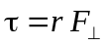

That this gives the same result as can be seen from the fact that F⊥ = F sinθ and r⊥ = r sinθ; so
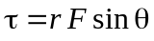

in either case. We can use any of the above equations to calculate the torque, whichever is easiest.

Since torque is a force times a distance, it is measured in units of N•m in SI units.

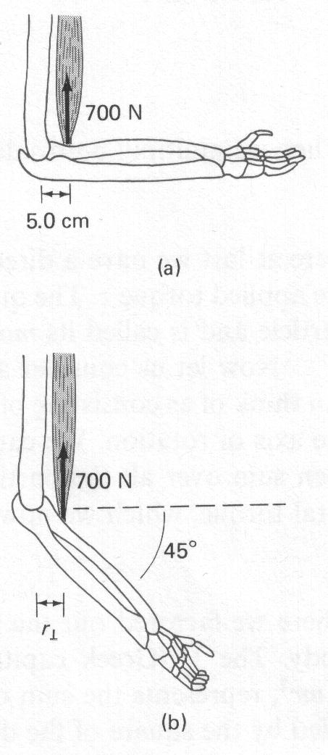
What is the torque applied by the biceps on the lower arm in figures (a) and (b). The axis of rotation is through the elbow joint and the muscle is inserted 5.0 cm from the elbow joint.

(a) F= 700 N and r⊥ = 0.050m

=(0.050m)(700N) = 35 N•m

(b) Because the arm is at a 45º angle, the lever arm is shorter:

= 25 N•m

A force of 55 N is applied perpendicular to the surface of a door at:

a) r = 0.80 m
b) r = 0.60 m
c) r = 0.0 m

Find the magnitude of the torque in each case.

- τ = F⊥ r = 55 N (0.80 m) = 44 N•m
- τ = F⊥ r = 55 N (0.60 m) = 33 N•m
- τ = F⊥ r = 55 N ( 0 m ) = 0

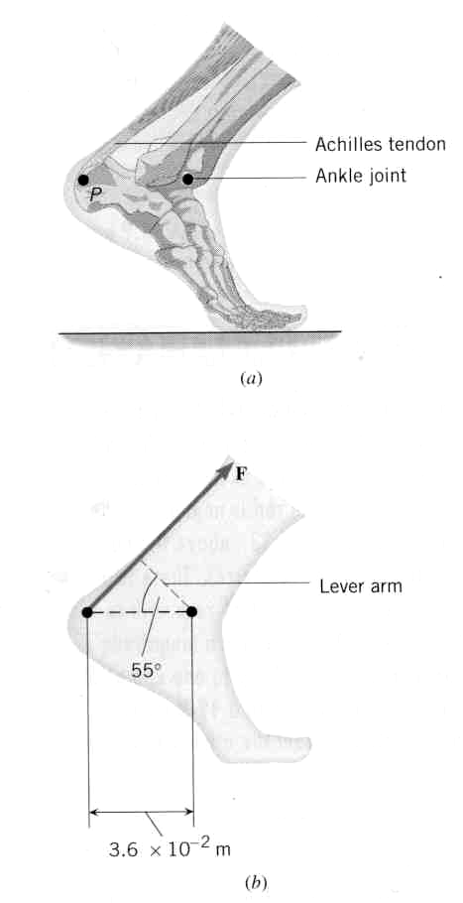
Muscles and tendons in our bodies produce torques about various joints. Here we see how the Achilles tendon produces a torque about the ankle joint. The lever arm is found from the geometry of the problem.

Diagram (a) shows the ankle joint and the Achilles tendon attached to the heel at point P. The tendon exerts a force of magnitude F = 720 N. Determine the torque (magnitude and direction) of this force about the ankle joint which is located 3.6 x 10⁻² m away from point P.

Solution: To calculate the magnitude of the torque, we can use the equation since we are given r, F, and θ.
= 15 N•m

Hand-in Assignment
1. The crank handle on an ice cream freezer is 0.20 m from the shaft. At some point in making ice cream a boy must exert a force of 50 N to turn the crank. How much torque does the boy apply about an axis through the shaft?
2. A post is driven perpendicularly into the ground and serves as the axis about which a gate rotates. A force of 12 N is applied perpendicular to the gate and acts parallel to the ground. How far from the post should the force be applied to produce a torque of 3.0 N•m?
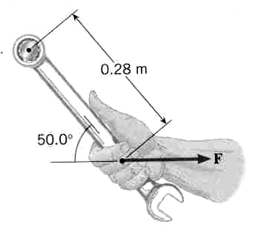
3. A person pushes on a door 0.50 m from the hinge with a force of 25 N at an angle of 35° to the door. What is the magnitude of the torque that the person applies about the hinge?
4. You are installing a new spark plug in your car, and the manual specifies that it be tightened to a torque of 45 N•m. Using the data in the drawing, determine the magnitude of the force you must exert on the wrench.

